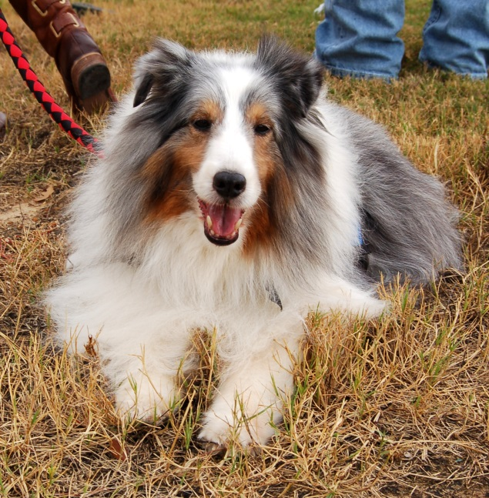
“Fawnwood No Greater Love,” call name “Tinsel”
Picture taken 12/1/2012

I want to share the very frightening, and fatal experience we had with our beloved pet therapy Sheltie over the past 6 months. I had talked with my veterinarian extensively about the heart worm/flea preventative drug, Trifexis before using it on my pets.

Tues, 5/14, we gave our dogs their 2nd dose ever of Trifexis; none had had any problems with the 1st dose in April (golden retriever, 2 std poodles, & our Sheltie).
Here’s Tinsel’s (Sheltie) story:
5/14 Tues: Trifexis given in AM (2nd ever dose)
5/16 Thur: Explosive diarrhea x 5 by noon (no other changes in prior daily routine); seen by our Vet same day due to severity of the diarrhea
5/17 Fri: 1st grand mal seizure
5/18 Sat: 2nd grand mal seizure
5/19 Sun: 3rd grand mal seizure
5/20 Mon: Seen by Vet early AM, all metabolic labs normal; tick screen neg. Started on zonisamide (anti-seizure med) at maximum dose/wt. Vet convinced that Tinsel had a brain tumor, but no neuro deficits or problems prior to the horrific seizures.
5/24 Fri: In consultation with Vet, decreased zonisamide by half because of apparent nausea, refusal of all food offered, and spacey affect.
5/25 Sat: Appetite still “ify” but running and barking some in backyard (had not run or barked since starting medication on Mon). Our “real” Tinsel seems to be coming back to us, and hopefully she will continue to recover. Thank you, Lord.

11/9/13, Sat: Sweet Tinsel had to be put to sleep tonight. Since 5/17, Tinsel would experience grand mal/tonic-clonic seizures each time we administered an antiflea or a heartworm preventative medication, regardless of whether it were topical or by mouth. She couldn’t even tolerate the single ingredient products that had been administered to her all of her life, her life before Trifexis. She was maintained on zonisamide, an anti-seizure medication, that was given twice a day for the last 6 months. We even gave the maximum dosage/wt several days before and after administering the flea or heartworm preventative. At this maximum dosage of zonisamide, Tinsel would stop eating after about a week, so we maintained Tinsel at half the maximum dosage by weight. Tinsel would be seizure-free until we administered a flea or a heartworm preventative. We tried administering the single ingredient products on alternate months, so as not to overtax her fragile neurological system. Friday, 11/8, Tinsel was given her prescribed heartworm preventative; she had been seizure-free for 3 months. Exactly 24 hours after receiving the heartworm preventative, Tinsel experienced a grand mal seizure…and then another 6 hrs later. We had to leave the house (for about 3 hrs) and returned to find our beloved Tinsel in status epilepticus (non-stop seizure activity). During some of her seizure activity, Tinsel bit herself so severely that she caused a pneumothorax, a punctured sac that holds each lung in place, on her left chest wall. She also had other bites on her left upper chest and leg. Tinsel appeared to be going into shock, so we rushed her to Texas A&M’s Small Animal Hospital Emergency, a premiere veterinary facility, 30 miles away. Tinsel experienced yet another grand mal seizure as she was taken into the examining area of the intensive care unit (ICU). The attending veterinarian did not think that Tinsel could tolerate the placing of a chest tube for treatment of the pneumothorax, and further sedation for treatment of her other severe injuries.

After 12 years of working with, and being loved by the best pet therapy/animal assisted activities animal I have ever known, I had to choose to end Tinsel’s life. And so, Tinsel passed away while I kissed her beautiful face and whispered my love to her. I can only hope that Tinsel could sense my presence, my scent, and, dear God, I hope that she heard me tell her how very, very much she was loved. We made our first pet therapy visit the night after Tinsel qualified with Therapy Dogs International (TDI) in Tulsa; she had just turned 9 months of age. I would have done absolutely anything for Tinsel, and yet, in retrospect, I killed my dog. I killed her when I chose to give my precious Tinsel Trifexis. A necropsy has been performed, and we are awaiting the evaluation of the tissue samples taken. The veterinary pathologist has stated to our veterinarian that on gross (visual) examination of Tinsel’s brain, there were no abnormalities that would have caused seizure activity.

Please DO NOT GIVE TRIFEXIS to any of your pets; it’s truly not worth the risk of grand mal seizures and worse! Here’s info that I found on the Net “after the fact” that might interest you: http://www.wsbtv.com/news/news/local/dog-owners-question-link-between-meds-and-deaths/nbpSg/ and .http://www.australian-shepherd-lovers.com/safe-medicatio.... These reactions in numerous dog breeds, including mixed breeds, are eerily similar to Tinsel’s. Please share Tinsel’s story and this warning with anyone you know with pets. Trifexis is not worth the risk of losing a beloved pet! Thank you for reading about Tinsel’s experience, and hopefully this discussion of our experience has provided important information to you!

